**Chapter–1 : Introduction**

**Variables**: It is used to hold or store data.

**Data Types**: A data type in a programming language is a set of data with predefined values.

1. System defined or primitive
2. User defined

**Data Structure**: Data structure is a particular way of storing and organizing data in a computer so that it can be used efficiently. A data structure is a special format for organizing and storing data.

1. Linear (array, string, stack, queue, linked list)
2. Non-Linear (tree, graph)

**ADTs**: To simplify the process of solving problems, we combine the data structures with their operations and we call this Abstract Data Types (ADTs). e.g.- stack, queue, linked list etc.

An ADT consists of two parts:

1. Declaration of data

2. Declaration of operations

**Algorithm**: An algorithm is the step-by-step unambiguous instructions to solve a given problem.

The goal of the analysis of algorithms is to compare algorithms (or solutions) mainly in terms of

running time but also in terms of other factors (e.g., memory, developer effort, etc.)

**How to compare algorithms:** Get the running time of a given algorithm as a function of the input size n (i.e., f(n)) and compare these different functions corresponding to running times. This kind of comparison is independent of machine time, programming style, etc.

**Rate of growth:** The rate at which the running time increases as a function of input is called rate of growth.

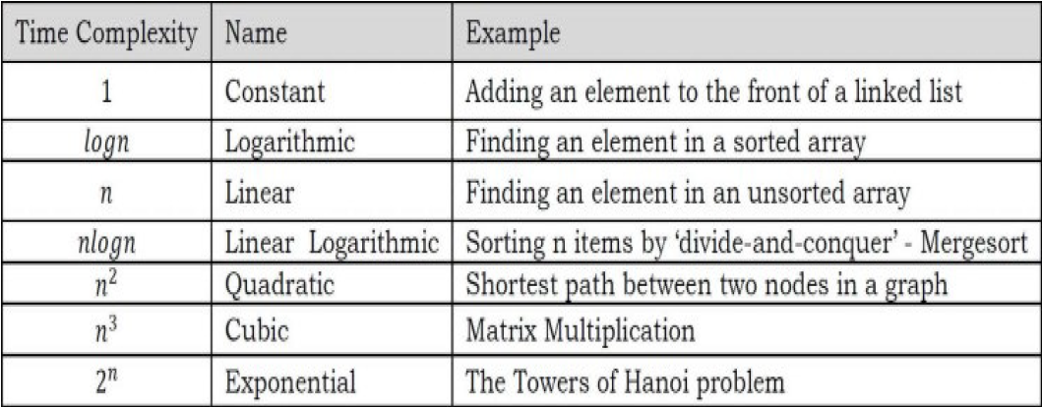

Types of Analysis:

1. Best Case
2. Average Case
3. Worst Case

**Lower Bound <= Average Time <= Upper Bound**

**Big (O) notation:** It gives the tight upper bound of the given function. Generally, it is represented as f(n) = O(g(n)). That means, at larger values of n, the upper bound of f(n) is g(n). e.g. f(n) = n4 + 100n2 + 10n + 50, then n4 is g(n). g(n) gives the maximum rate of growth for f(n) at larger values of n. Or it is the asymptotic tight upper bound.

It is smallest rate of growth greater than or equal to given algorithm’s rate of growth.

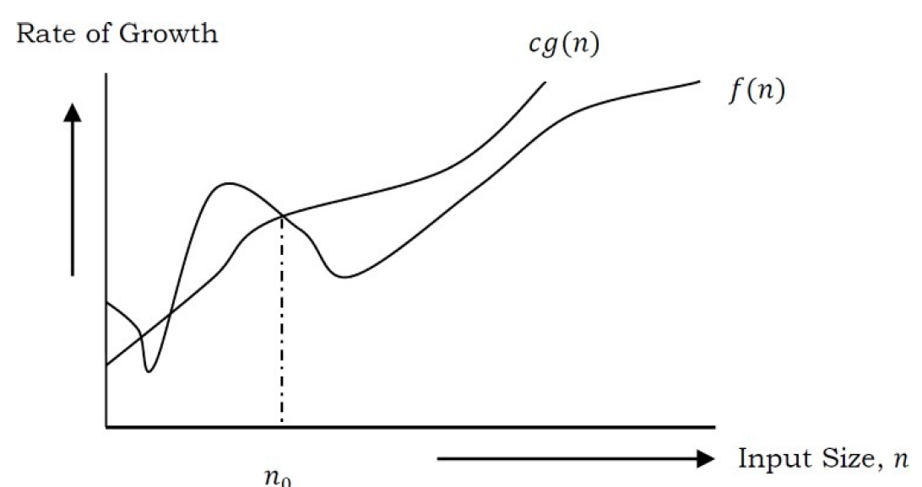

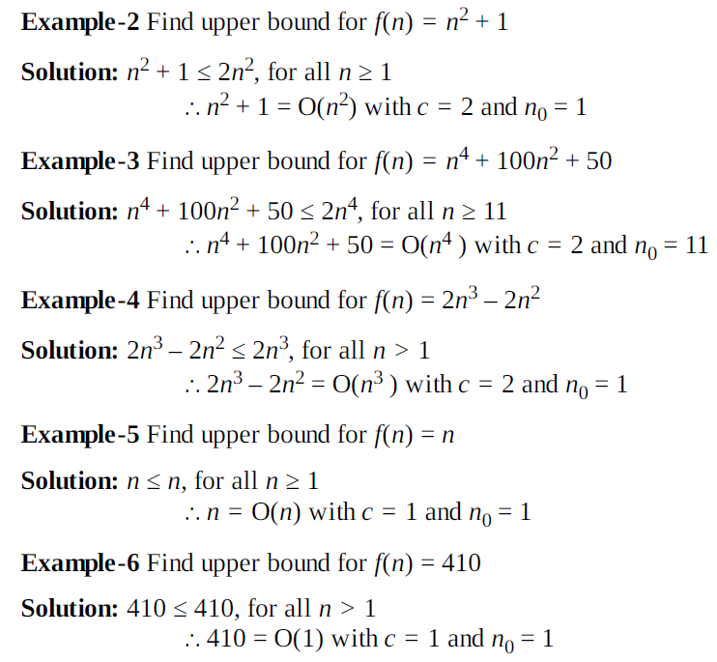

--------------------------------------------------------------------------------------------------------------------------------------

**Omega (Q) notation:** It gives the tighter lower bound of the algorithm and represented as f(n) = Ω(g(n)). At larger values of n, the tighter lower bound of f(n) is g(n). e.g. f(n) = 100n2 + 10n + 50, g(n) is Ω(n2).

It is largest rate of growth less than or equal to given algorithm’s rate of growth.

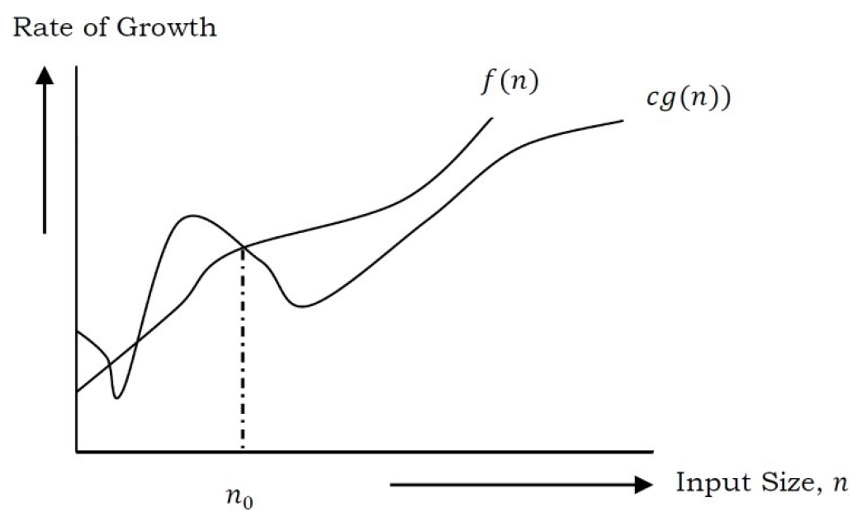

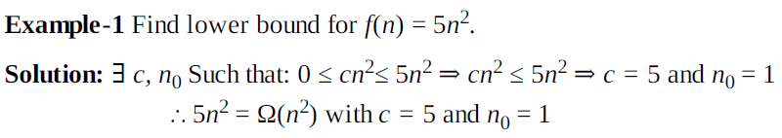

--------------------------------------------------------------------------------------------------------------------------------------

**Theta (Θ) notation:** It decides whether the upper and lower bounds of a given algorithm are the same. The average running time of an algorithm is always between the lower bound and the upper bound.

Θ(g(n)) is the set of functions with the same order of growth as g(n).

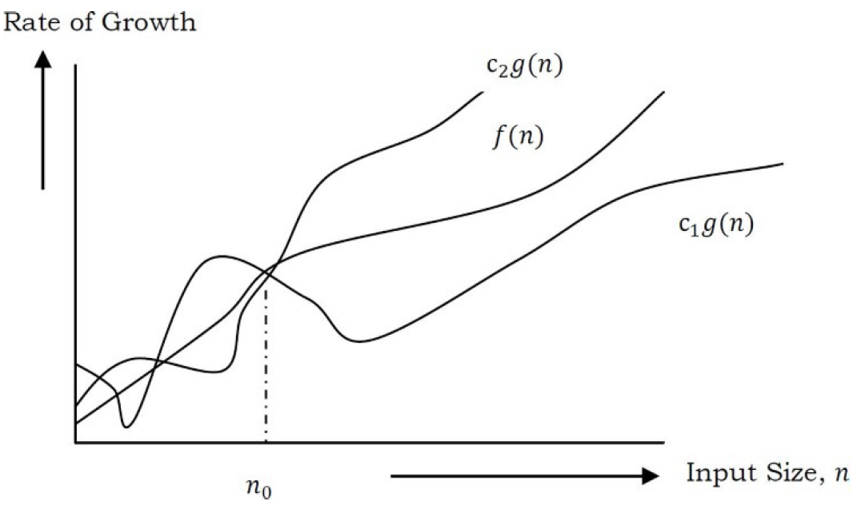

Why it is called asymptotic?

Because we are trying to find a curve g(n) which is approximate to f(n), and in mathematics this function is called asymptotic curve.

Running time:

1. For single loop = n;
2. For consecutive statement = sum

e.g. loop + nested loop= n^2+n = O(n^2)

3. For if-else = it depends upon statement under both the blocks.

4. For logarithmic = (log n) if problem size is reduced by 2

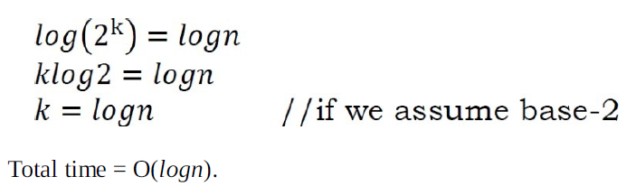

Some formulae-

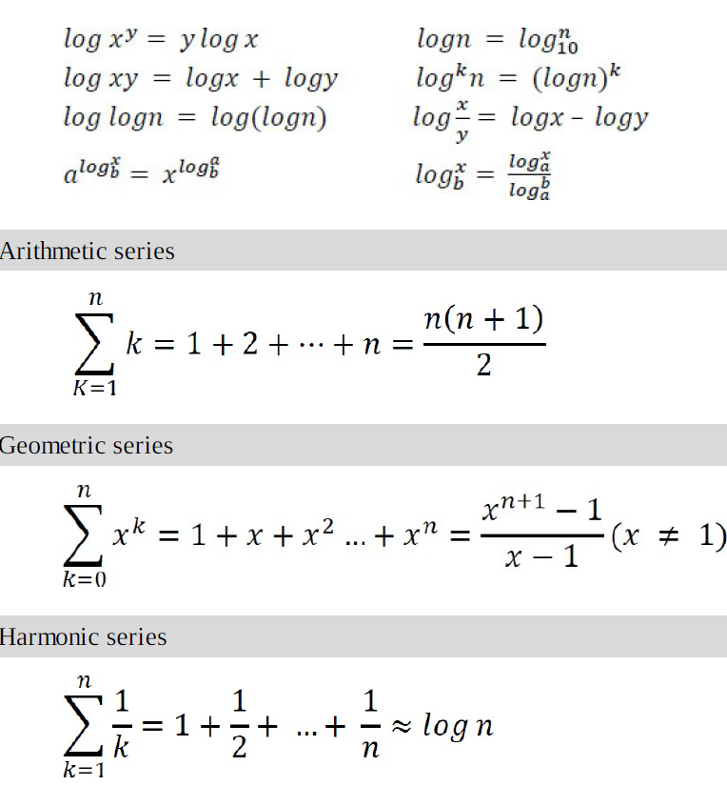

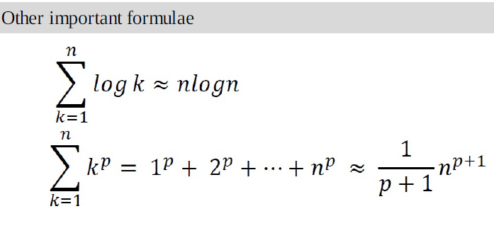

**--------------------------------------------------------------------------------------------------------------------------------------**

**Amortized Analysis-** It is used to analysis algorithm when different input values affect the running time of other operations.

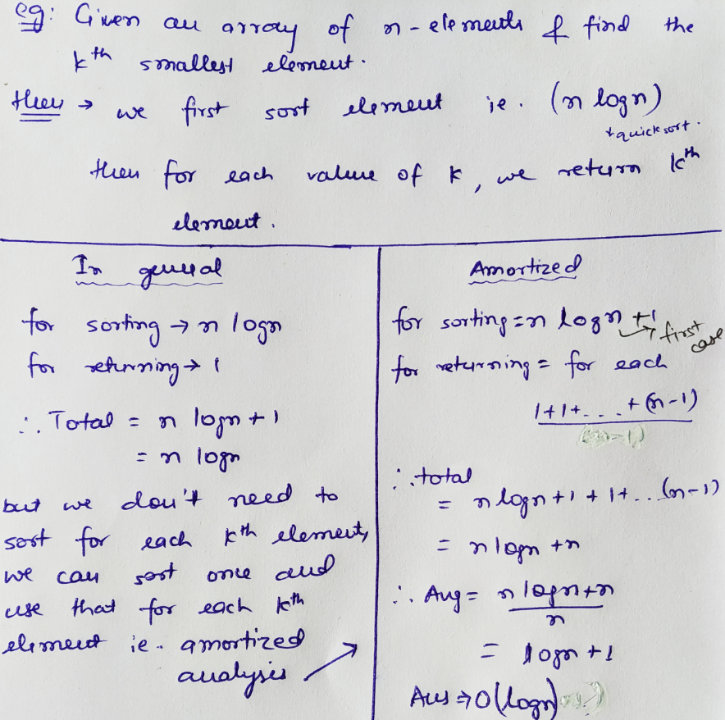

**🡪**If there are n loops and last loop contains break; then overall complexity becomes (n-1).

Important (Revise)

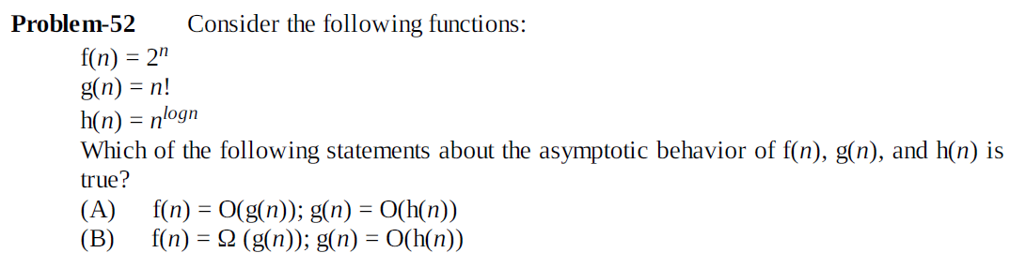

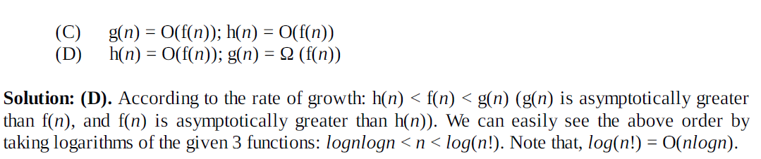

**=============================================**

**Chapter-2:Recursion & Backtracking**

->Any function which calls itself is called recursive.

->This case, where the function does not recur, is called the base case. The former, where the function calls itself to perform a subtask, is referred to as the recursive case. E.g.

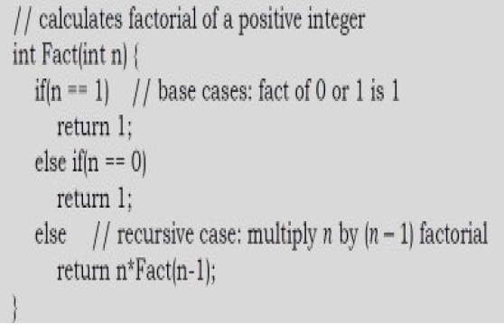

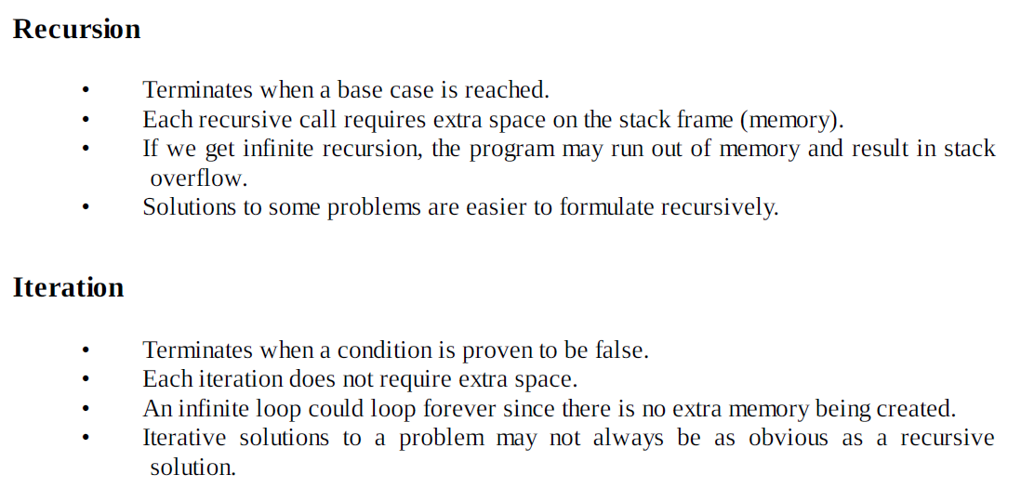

->Generally, iterative solutions are more efficient than recursive solutions [due to the overhead of function calls].

**Tower of Hanoi - Algorithm :-**

• Move the top (n – 1) disks from Source to Auxiliary tower,

• Move the nth disk from Source to Destination tower,

• Move the (n – 1) disks from Auxiliary tower to Destination tower.

• Transferring the top (n – 1) disks from Source to Auxiliary tower can again be thought

of as a fresh problem and can be solved in the same manner. Once we solve Towers of Hanoi with three disks, we can solve it with any number of disks with the above algorithm.

**Backtracking:** It follows brute force approach. It systematically searches for a solution among all available options. In backtracking, we start with one possible option out of many available options and try to solve the problem if we get the result then print it else, we come back and follow other option.

->It is always slow.

**=============================================**

**Chapter-3: Linked List**

**Advantage of Linked list:**

->No wastage of memory.

**Disadvantage of linked list:**

->Array is random-access, which means it takes O (1) while linked lists take O(n) for access to an element in the list in the worst case.

->Linked list wastes memory using pointers.

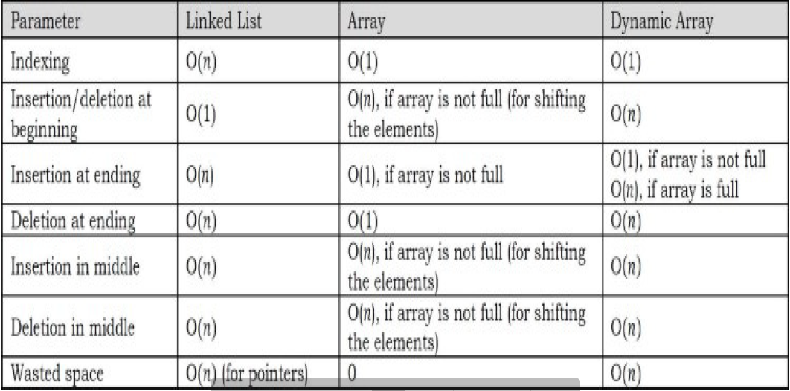

Types of Linked List:

**1.Singly linked list-**

1. Traversing

Complexity: O(n), for scanning the list of size n.

1. Insertion

Complexity: O(n) 🡪same if insertion is done in sorted linked list.

1. Deletion

Complexity: O(n)

1. Reversal

Complexity: O(n)

---------------------------------------------------------------------------------------------------------

**2.Doubly Linked list-**

Disadvantage-

1. Requires extra pointer.
2. Insertion and deletion require more manipulation.
3. Insertion

Complexity: O(n)

1. Deletion

Complexity: O(n)

---------------------------------------------------------------------------------------------------------

**3.Circular Linked List-**

General complexity: O(n)

🡪 Go through all operations of circular linked list once again**

Uses:

1. Implementing stacks and queues.
2. Managing computer’s resources.

---------------------------------------------------------------------------------------------------------

**4.Unrolled linked list:**

An unrolled linked list stores multiple element in each node (block for our convenience). In each block, a circular linked list is used to connect all nodes.

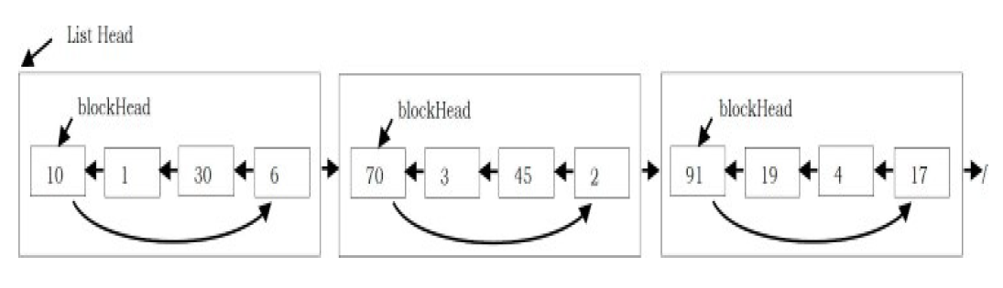

🡪It can be said as a combination of linked list and arrays.

🡪More efficient in storing elements.

🡪It reduces overhead of numerous pointers.

**Advantages:**

* Good cache management.
* In comparison to ordinary linked list, it requires less storage space for pointers/references.
* It performs operations like insertion, deletion, and traversal more quickly than ordinary linked lists (because search is faster).

**Disadvantages:**

* The overhead per node is comparatively high than singly linked lists.

**Code:**

#define N 5

struct node

{

int arr[N];

struct node *ptr;

int capacity;

};

struct node *ul1;

void display(struct node *ull)

{

int i ;

while (ull != NULL)

{

for (i=0; i< ull->capacity; i++)

printf("%d ",ull->arr[i]);

ull=ull->ptr;

}

}

int main()

{

int threshold;

threshold=((N/2)+1);

struct node* head = NULL;

struct node* second = NULL;

struct node* third = NULL;

struct node* fourth = NULL;

head = (struct node*)malloc(sizeof(struct node));

second = (struct node*)malloc(sizeof(struct node));

third = (struct node*)malloc(sizeof(struct node));

fourth = (struct node*)malloc(sizeof(struct node));

head->capacity= threshold;

head->arr[0] = 1;

head->arr[1] = 2;

head->arr[2] = 3;

head->ptr = second;

second->capacity = threshold;

second->arr[0] = 4;

second->arr[1] = 5;

second->arr[2] = 6;

second->ptr = third;

third->capacity = threshold;

third->arr[0] = 7;

third->arr[1] = 8;

third->arr[2] = 9;

third->ptr = fourth;

fourth->capacity=threshold;

fourth->arr[0] = 10;

fourth->arr[1] = 11;

fourth->arr[2] = 12;

fourth->ptr=NULL;

display(head);

return 0;

}

**NOTE:-**

capacity🡪it is the capacity of number of elements.

🡪if number of elements i.e. capacity==size i.e. N then we cannot insert any element.

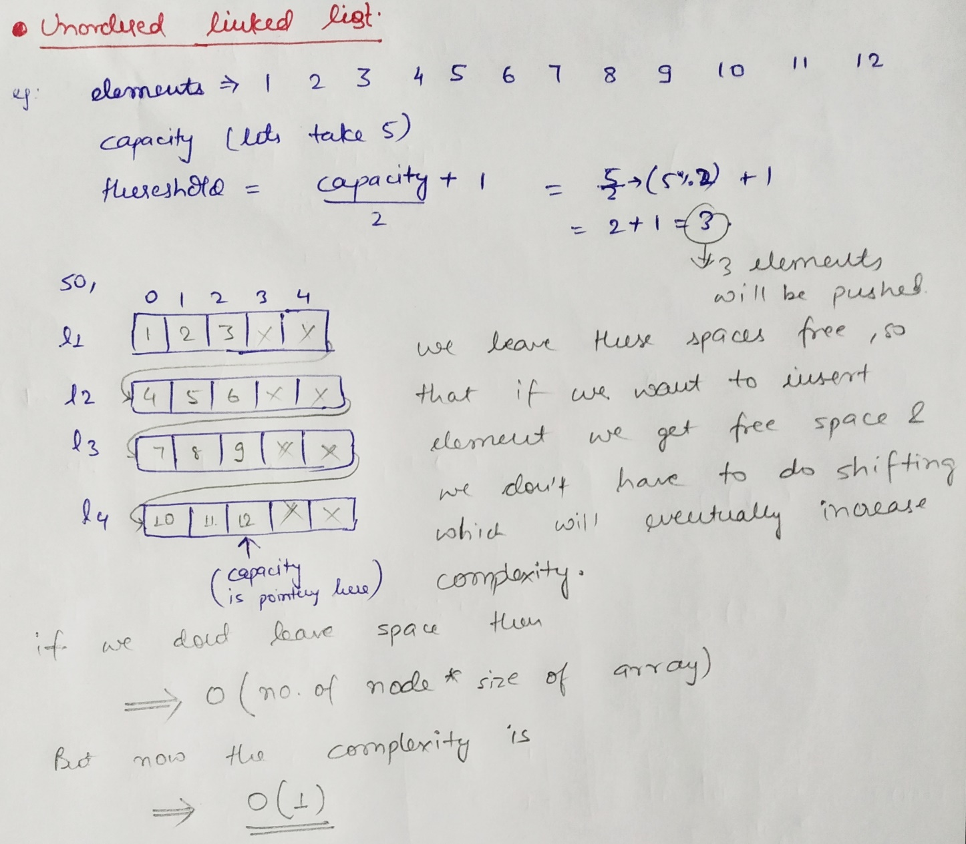

--------------------------------------------------------------------------------------------------

**5.Skipped Linked List**

🡪Skip list can be used as an alternative to balanced binary trees because skip lists allow quick search, insertion, and deletion of elements.

🡪Skipped List is a kind of list having additional pointers to skip intermediate nodes can.

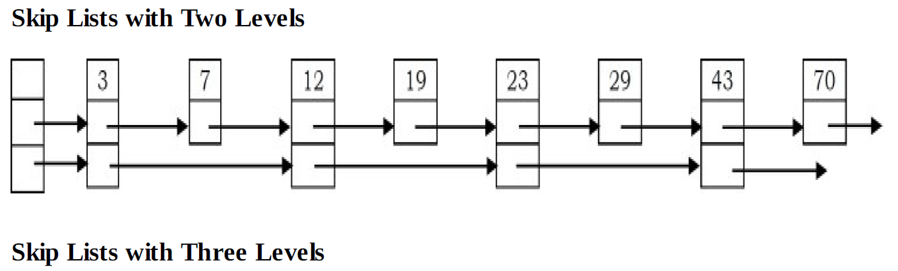

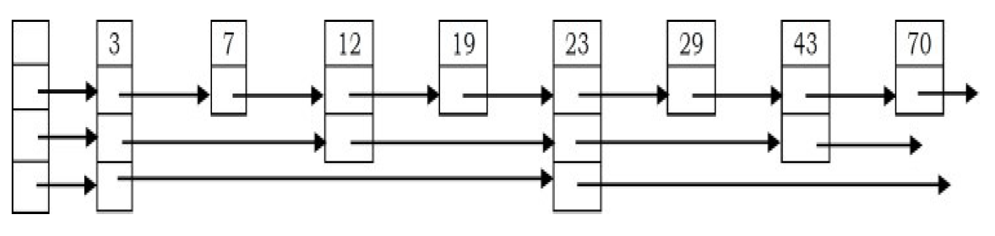

We reduced steps to search for a number by adding skips. But many skips cannot be added as it requires pointers which will increase space complexity.

**Complexity**: O (log n)

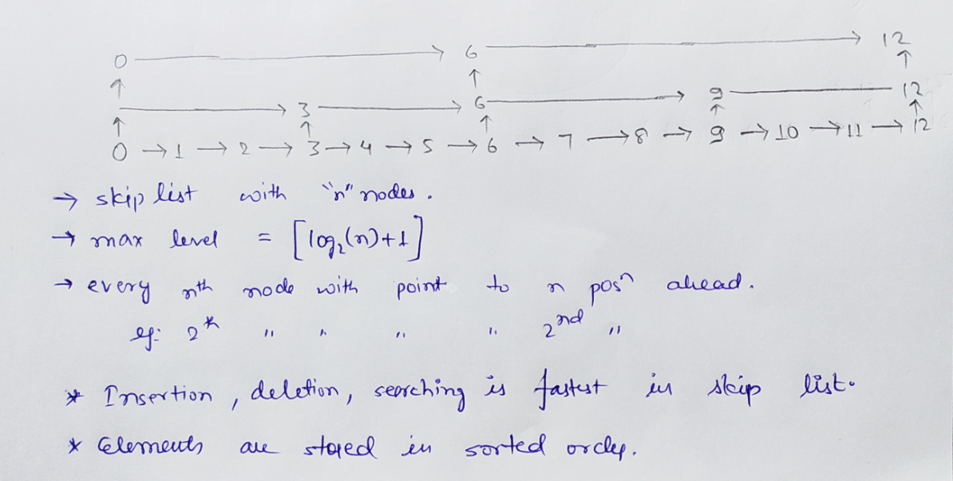

Code-page-120.

**Floyd Cycle Finding Algorithm:** To find loop in linked list

This works because the only way a faster moving pointer would point to the same location as a slower moving pointer is if somehow the entire list or a part of it is circular.

Complexity= O(n)

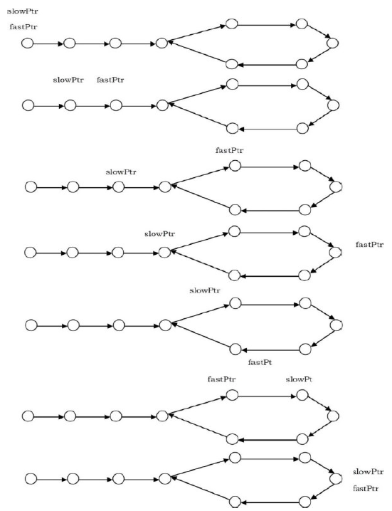

Code:

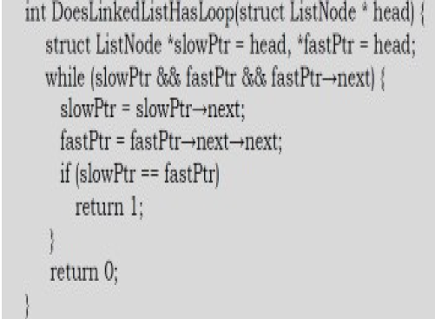

---------------------------------------------------------------------------------------------------------

**Merge Sort**- Merging of two singy Linked List

**a.Recursion**

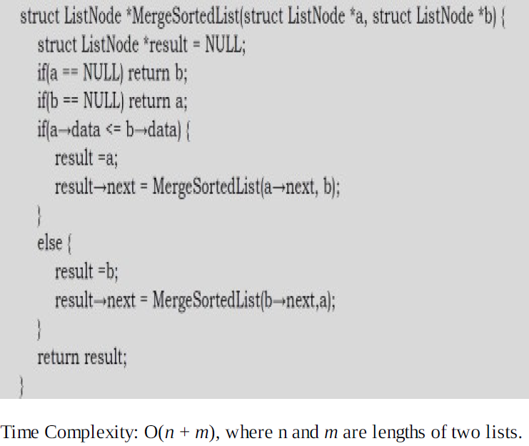

**b.Iteration**

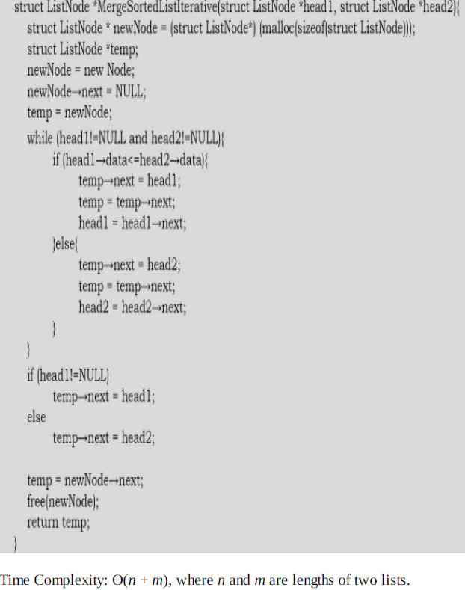

---------------------------------------------------------------------------------------------------------

Question: If we want to concatenate two linked lists which of the following gives O (1) complexity?

Answer: *Doubly Circular Linked List*, as we do not need to traverse whole list.

**=============================================**

**Chapter-3 : Stacks**

A stack is an ordered list in which insertion and deletion are done at one end, called top. The last element inserted is the first one to be deleted. Hence, it is called the Last in First out (LIFO) or First in Last out (FILO) list.

**Push**-Insertion of data onto stack; **Pop**- Deletion of data from stack.

**Underflow**- Pop from empty stack; **Overflow**- Push in full stack.

**Direct applications**

• Balancing of symbols

• Infix-to-postfix conversion

• Evaluation of postfix expression

• Implementing function calls (including recursion)

• Page-visited history in a Web browser [Back Buttons]

• Undo sequence in a text editor

• Matching Tags in HTML and XML

-----------------------------------------------------------------------------------------------------------------

Complexity of **Stack implementation through Static Array:**

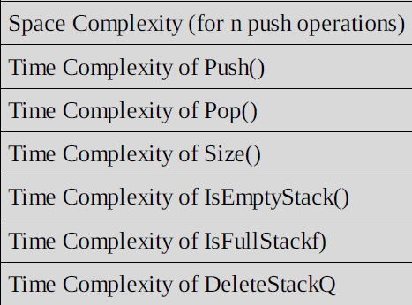 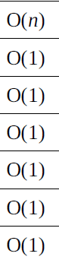

Limitation- Stack’s maximum size is fixed in the starting.

Complexity of **Stack implementation through Dynamic Array:**

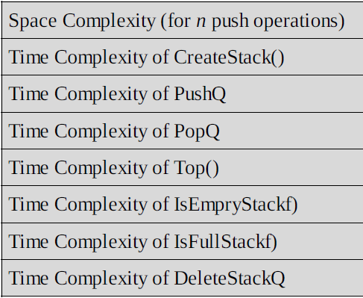 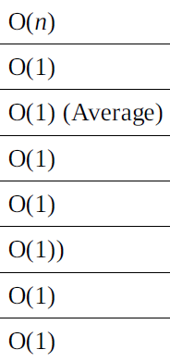

---------------------------------------------------------------------------------------------------------

Complexity of **Stack implementation through Linked List:**

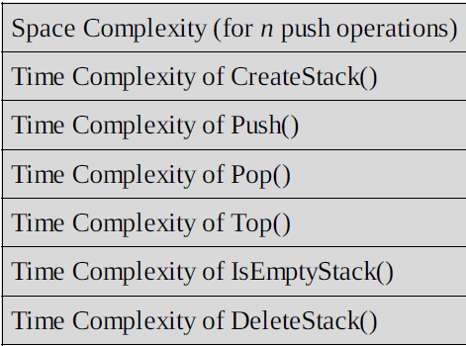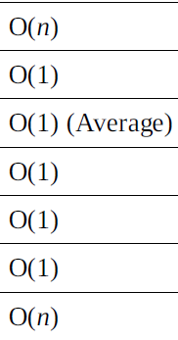

**-----------------------------------------------------------------------------------------------------------------**

**Amortized analysis:**

Incremental Strategy- The amortized time (average time per operation) of a push operation is O(n) [O(n2)/n].

Doubling Strategy- In this method, the amortized time of a push operation is O(1) [O(n)/n].

Note:

In case of infix to postfix or prefix, when there are multiple operators of same precedence then approach them left to right.

e.g. a+b+[*cd] = +[ab]+[*cd] = ++ab*cd (<-- Prefix)

**Infix to Postfix:**

**Algorithm**  
**1.** Scan the infix expression from left to right.  
**2.** If the scanned character is an operand, output it.  
**3.**Else,

* 1. If the precedence of the scanned operator is greater than the precedence of the operator in the stack, push it.
  2. Else, Pop all the operators from the stack which are greater than or

equal to in precedence than that of the scanned operator. After

doing that Push the scanned operator to the stack.

**4.** Repeat steps 2-4 until infix expression is scanned.  
**5.** Print the output.  
**6.**Pop and output from the stack until it is not empty.

[Greater is pushed, equal and less will be popped]

**Another Algorithm:**

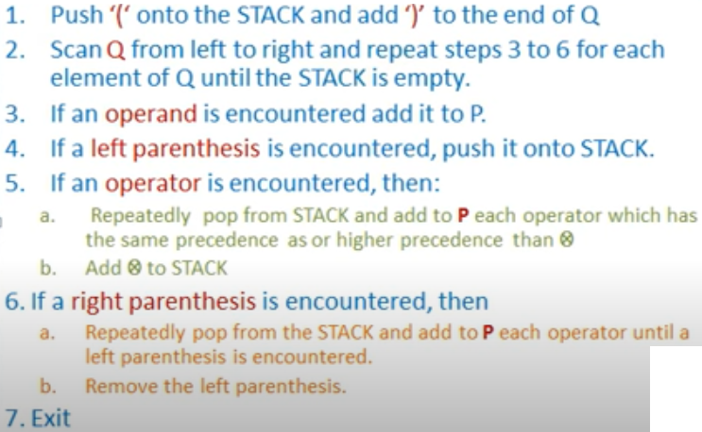

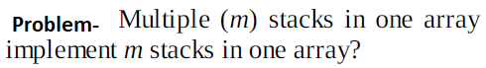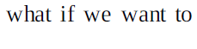

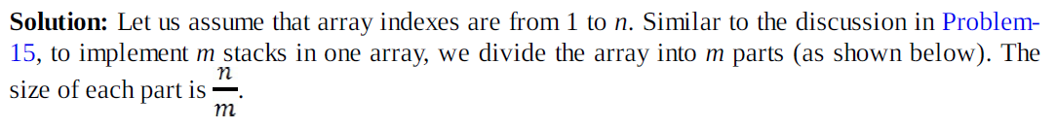

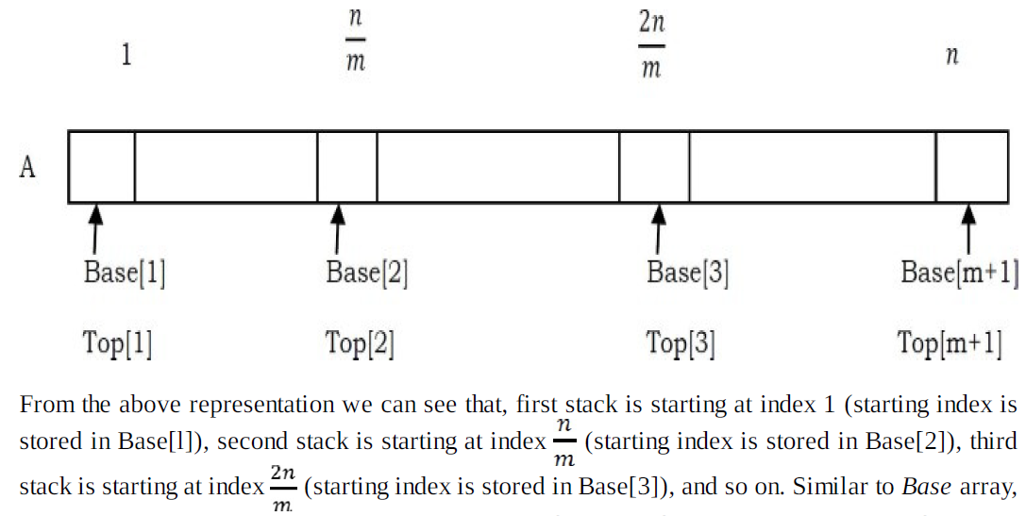

Push

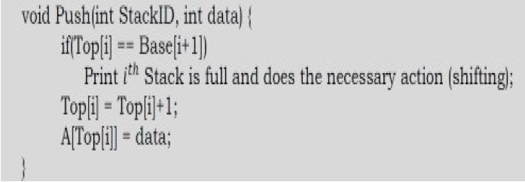

Pop

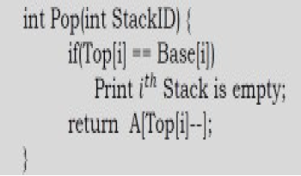

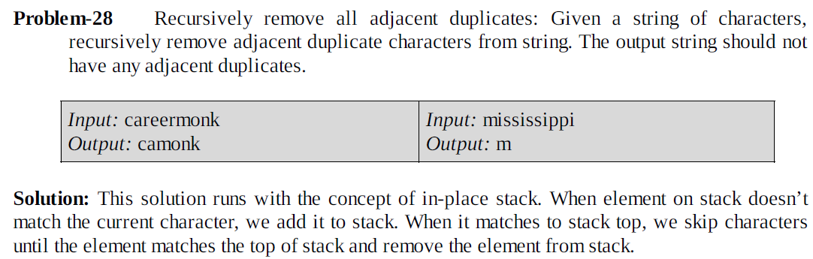

Complexity=O(n)

**=============================================**

**Chapter-4: Queue**

A queue is an ordered list in which insertions are done at one end (rear) and

deletions are done at the other end (front). The first element to be inserted is the first one to be deleted. Hence, it is called First in First out (FIFO) or Last in Last out (LILO) list.

**EnQueue**-insertion of element

**DeQueue**-deletion of element

**Underflow**- dequeuing from empty queue.

**Overflow**- enqueuing into full queue.

**Direct Applications**

• Operating systems schedule jobs (with equal priority) in the order of arrival (e.g., a print queue).

• Simulation of real-world queues such as lines at a ticket counter or any other.

• Multiprogramming.

• Asynchronous data transfer (file IO, pipes, sockets).

• Waiting times of customers at call centre.

• Determining number of cashiers to have at a supermarket.

**Indirect Applications**

• Auxiliary data structure for algorithms

• Component of other data structures.

**Implementations:**

**Using Array:**

Insertion and deletion both will have same complexity.

Complexity= O (1)

**---------------------------------------------------------------------------------------------------------**

**Using Circular Array:**

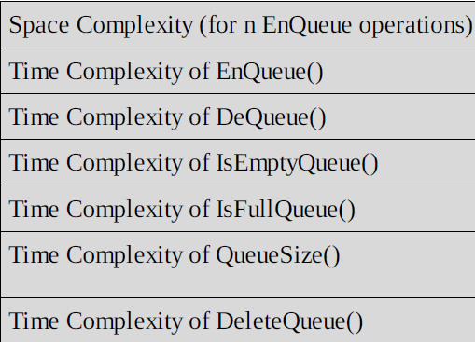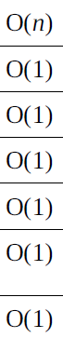

Complexity= O (1)

**Limitations:** The maximum size of the queue must be defined as prior and cannot be changed.

No of elements = (rear - front + 1)

---------------------------------------------------------------------------------------------------------

**Using two stacks:**

Complexity= O (1)

**Using Linked List:**

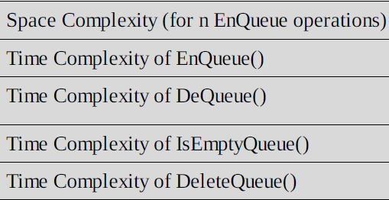 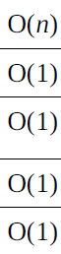

Complexity= O (1)

**---------------------------------------------------------------------------------------------------------**

How to reverse a queue?

Code:

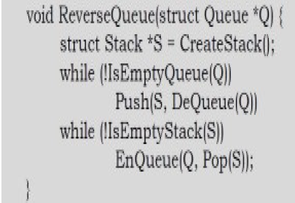

Complexity= O (n)

**================================================================**

**=============================================**

**Chapter-5: Tree**

It is a non-linear data structure. It can represent data which are in the form of hierarchy.

**1. Root**- A node having no parent. A tree can have only one node.

**2. Edge**- A link between parent node and child node.

**3. Leaf Node** – A node having no child.

**4. Level** – The set of all nodes at a given depth is called level of that tree. The root node is a level 0.

**5. Depth** – The path-length from root node to that node.

**6. Height** – The length of path from root node to the deepest node.

**7. Size -** Number of nodes present in a tree.

**For a given tree, both height and depth are same.**

**Skew Tree –** If all the nodes of a tree has only one child. It is of two types – left skew tree and right skew tree.

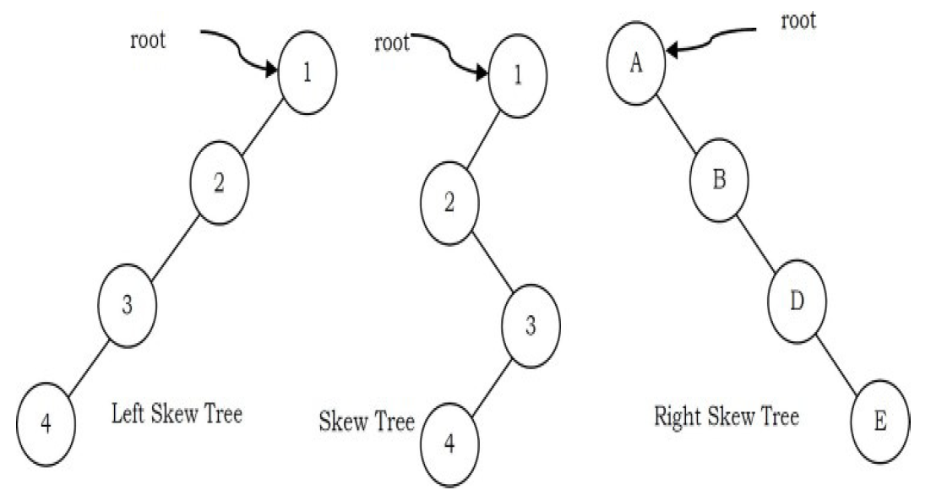

**Binary Tree –** If each node has either 0 child-node / 1 child-node / 2 child-node. **(Empty tree** is also a binary tree.)

Child-node=0/1/2

**Types:**

**1. Strict Binary Tree-** If each node has exactly two child-node or zero child-node.

Child-node=0/2

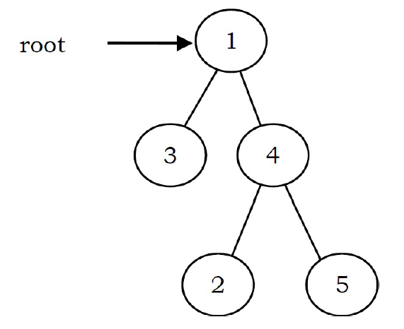

**2. Full Binary Tree-** If a binary tree has exactly two child node and all the leaf nodes are at the same level. It is also called **Perfect** **Binary Tree.**

Child-node=0/2

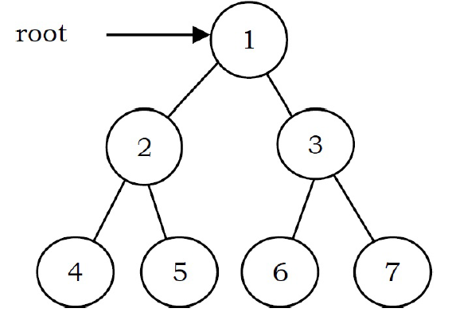

**3. Complete Binary Tree-** A complete binary tree is a binary tree in which all the levels , except the last level are completely filled, and in the last level all nodes are to the **left as much as possible**.

Note: All leaf elements must lean towards the left.

A complete binary tree might not have a right sibling.

A complete binary tree does not have to be a full binary tree.

Child-node=0/1/2

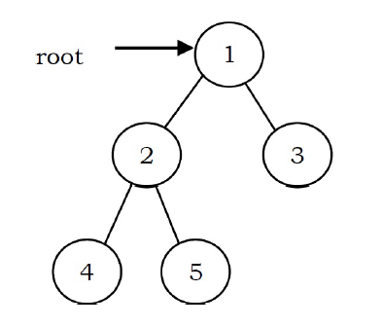

**4. Balance Binary Tree-**  When the depth of the subtrees of all its nodes do not differ by more than 1.

Child-node=0/1/2

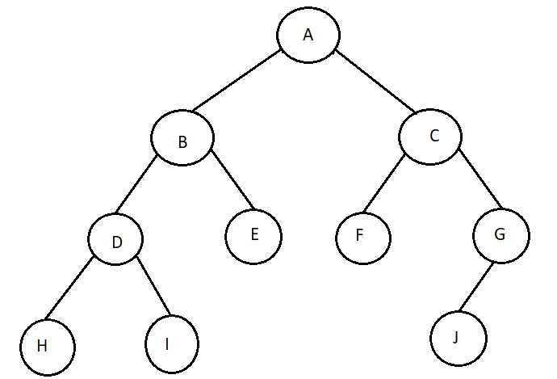

---------------------------------------------------------------------------------------------------------

**Properties of Full - Binary trees:**

🡪Number of nodes **at level h** = (2^height)

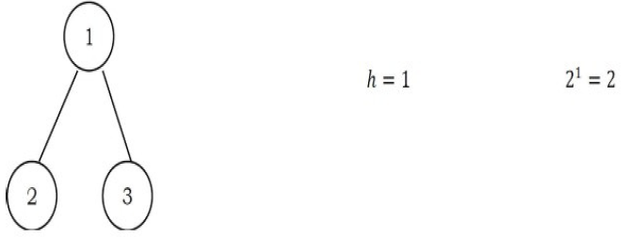

🡪Total number of nodes in a full binary tree is

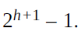

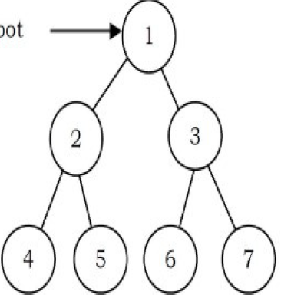 Nodes = 2^3 – 1 =7

🡪 Total leaf nodes = (2^h)

e.g. Total leaf node in above tree = 2^2 = 4

🡪Number of NULL links (wasted pointers) = nodes + 1

e.g. Total NULL pointers = n+1 = 7+1 = 8

---------------------------------------------------------------------------------------------------------

**Applications of Binary Trees:**

• Expression trees are used in compilers.

• Huffman coding trees that are used in data compression algorithms.

• Binary Search Tree, which supports search, insertion, and deletion on a

collection of items in O (log n) (average).

• Priority Queue, which supports search and deletion of minimum (or maximum) on a collection of items in logarithmic time (in worst case).

---------------------------------------------------------------------------------------------------------

Diameter of Binary tree - The diameter of a binary tree is the length of the longest path between any two nodes in a tree. This path may or may not pass through the root.

**Note:** The length of path between two nodes is represented by the number of edges between them.

**Time Complexity:** O(n2)

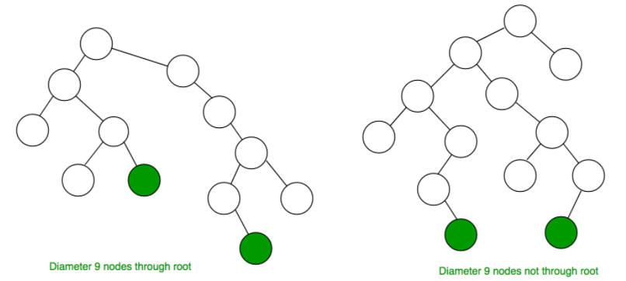

---------------------------------------------------------------------------------------------------------

**Tree Traversal Methods:**

1. Pre-Order Traversal [ ROOT 🡪 LEFT 🡪 RIGHT.]

Time Complexity: O(*n*). Space Complexity: O(*n*). 🡨Iterative & Recursive.

---------------------------------------------------------------------------------------------------------

2. In-Order Traversal [ LEFT 🡪 ROOT 🡪 RIGHT.]

Time Complexity: O(*n*). Space Complexity: O(*n*). 🡨Iterative & Recursive.

---------------------------------------------------------------------------------------------------------

3. Post-Order Traversal [ LEFT 🡪 RIGHT 🡪 ROOT.]

Time Complexity: O(*n*). Space Complexity: O(*n*). 🡨Iterative & Recursive.

---------------------------------------------------------------------------------------------------------

4. Level-Order Traversal

🡪 Use a queue and push nodes into it (left -> right ), pop node from queue and push the popped node’s left and right.

🡪 It is inspired from Breadth First Traversal (BFS – graph).

**Generic Trees (N-ary Trees)**

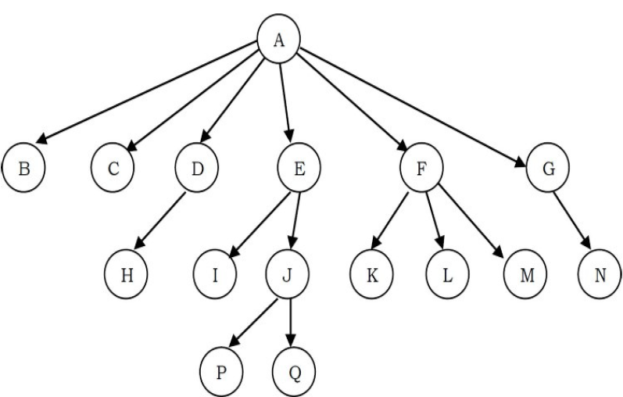

In advance we do not know how many children any node can have so we cannot create its structure like we did for binary tree.

**Better representation :** Link between parent and first child and links between all children of same parent then it solves our problem. This representation is sometimes called first child/next sibling representation.

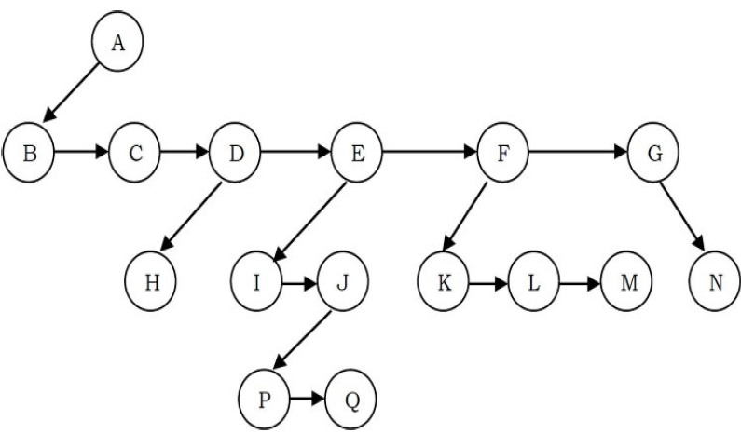

Actual representation :

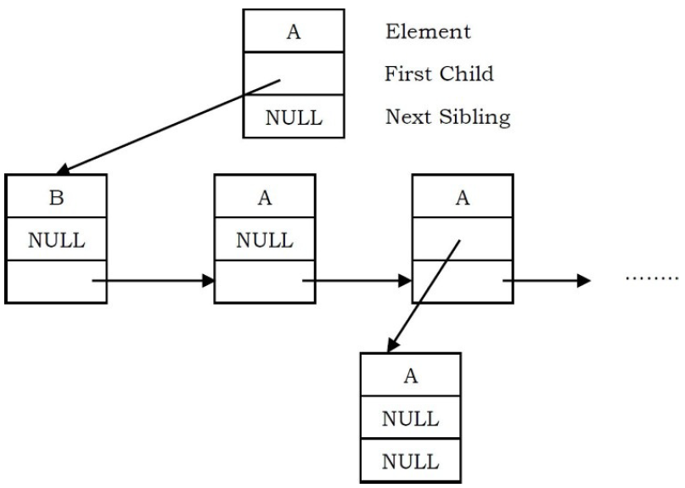

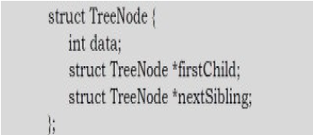

---------------------------------------------------------------------------------------------------------

**Threaded Binary Trees (Stack or Queue-less Tree)**

🡪The binary trees which store information (predecessor/successor information) in NULL pointers are called threaded binary trees.

**Reasons for using threaded binary tree:**

1.The storage space required for the stack and queue is large.

2.Most pointers in any binary tree are NULL. For example, a binary tree with n nodes has (n + 1) NULL pointers and these were wasted.

3.It is difficult to find successor node (pre-order, in-order and post-order successors) for a given node.

**Types:**

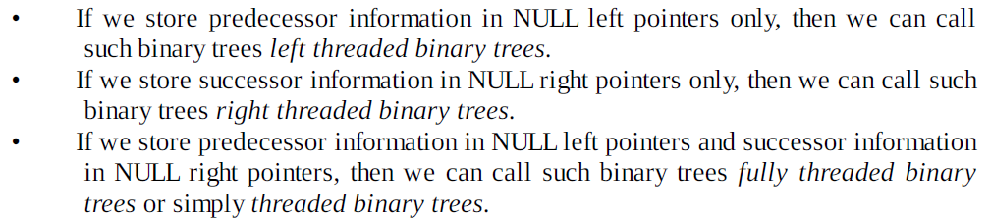

---------------------------------------------------------------------------------------------------------

**Types of fully threaded binary tree:**

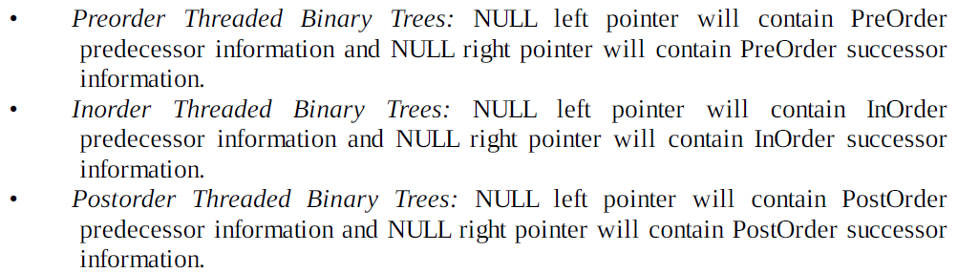

**Structure:**

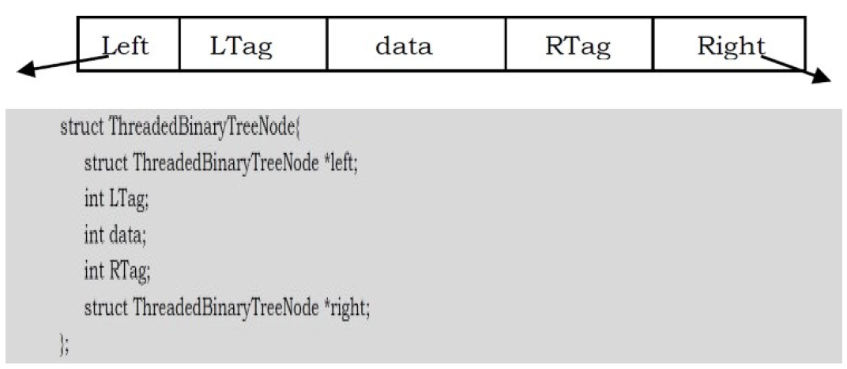

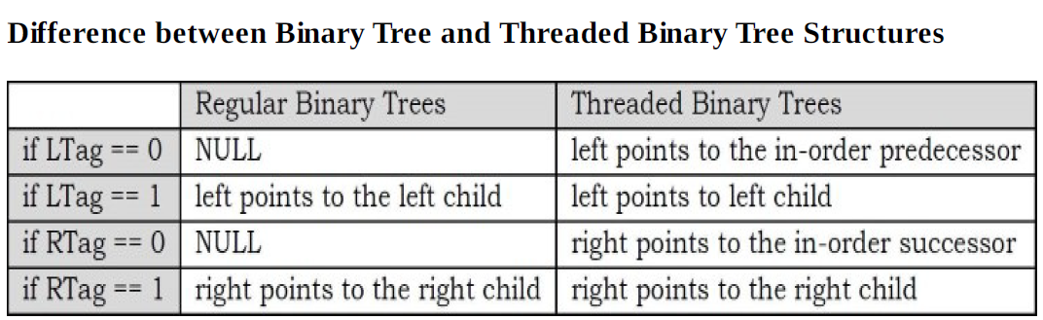

---------------------------------------------------------------------------------------------------------

**Expression Tree**

A tree representing an expression is called an expression tree. In expression trees, leaf nodes are operands and non-leaf nodes are operators. That means, an expression tree is a binary tree where internal nodes are operators and leaves are operands.

Expression tree for (A + B * C) / D :

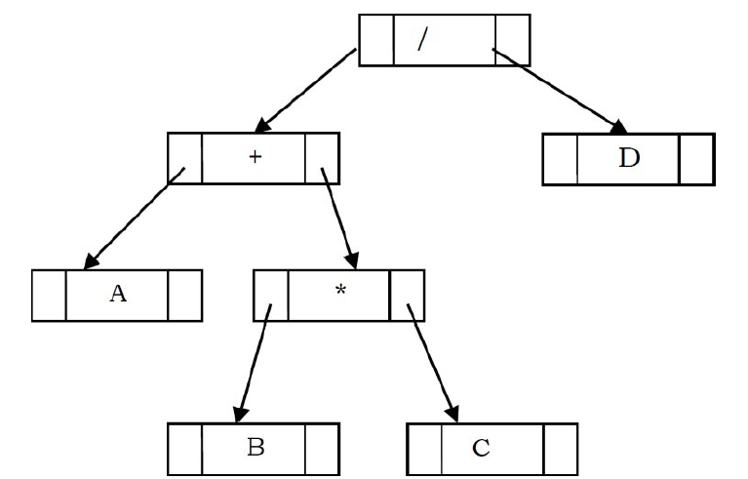

---------------------------------------------------------------------------------------------------------

**Binary Search Tree (BST)**

In binary search trees, all the left subtree elements should be less than root data and all the right subtree elements should be greater than root data. This is called binary search tree property. Note that, this property should be satisfied at every node in the tree.

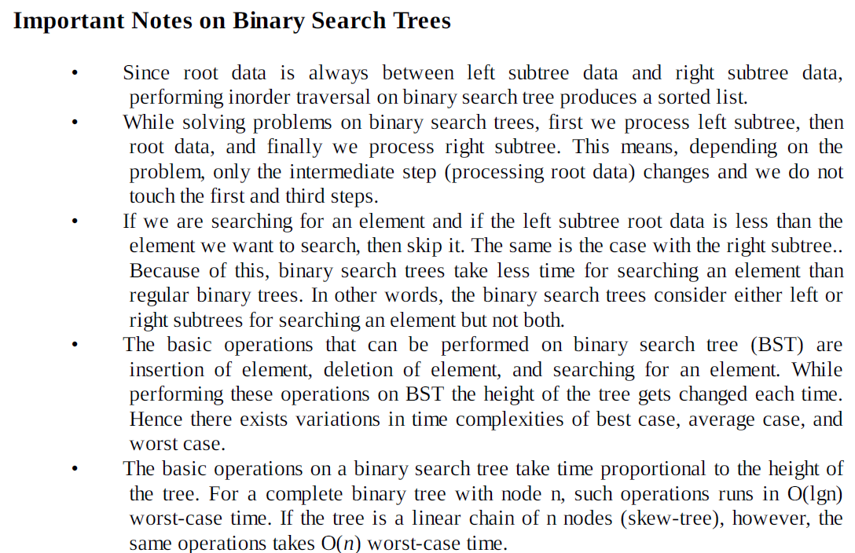

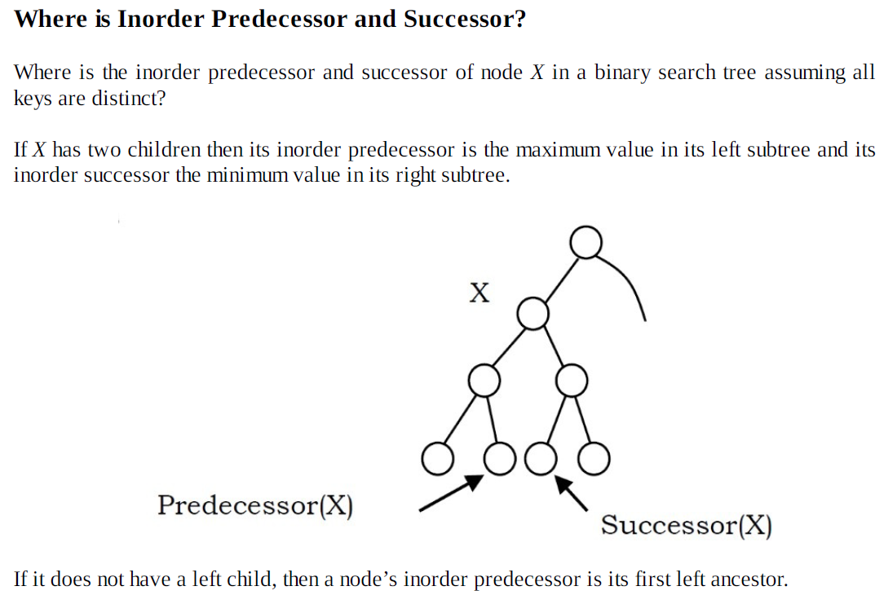

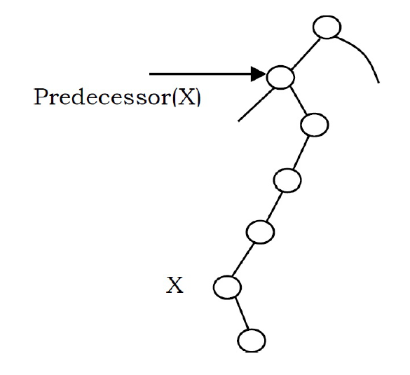

To be continued…..